LISTENING TASK
JAMIE OLIVER. CELEBRITY CHEF INTERVIEW
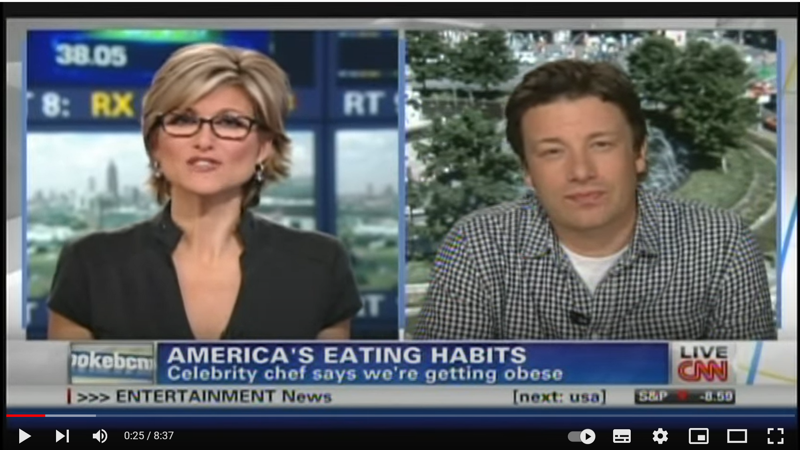
Source: https://www.youtube.com/watch?v=98Ed7BbGOPo

TASK. You will hear part of a CNN TV interview with celebrity chef Jamie Oliver. For questions 1-7, complete the sentences in a maximum of FOUR words. Write your answers in the grid provided below. The first one (0) has been done for you as an example. You will hear the recording twice.
NOTE: The video is 8:37 minutes long. This exercise has been designed for the first 5:46 minutes.

Jamie Oliver is on TV to talk about an event called (0) Food Revolution Day. The (1) ……………….……………….………………. estimate that 60% of adults have weight problems.
According to Jamie Oliver, the main cause of death in the UK and the USA is (2) ……………….……………….……………….
Among other things, Jamie Oliver has been (3) ……………….………………. governments and doing documentaries to raise awareness about the problems caused by obesity.
Many things have changed in the food industry over the last forty years, including (4) ……………….……………….. and the technology of (5) ……………….……………….
What we’re trying to do on Food Revolution Day is congratulate all those groups and organizations and (6) ……………….…………………….……. and also give them more confidence to keep doing the great work they’re doing.
At The Heart Attack Grill, if you weigh (7) ……………….….……. you do not have to pay for your food.
Some of the people who tried the quadruple bypass burger (8) …………………….……. and needed medical attention.
This is a (9) ….……………………….……. that people are buying into as there’s plenty of business at The Heart Attack Grill.
Both countries, the UK and America are in crisis, and the biggest killer is not given the attention it should because it’s not (10) …………………….……. enough.
America is an amazing and diverse country, in other words, a (11) …………………….……. from all around the world, so there’s a lot to celebrate.

 | Your answer
0 | Food Revolution Day
1
2
3
4
5
6
7
8
9
10

